Getting the most out of Visual Studio

Using a C++ Dynamic Link Library (DLL) with Visual Basic

Written By: Erik Stites
Introduction:
After struggling to find decent examples of how to implement DLLs in Visual Basic, I decided to attack the problem on my own. There was more frustration in finding a solution than actual time put into it. I will begin by explaining the C++ code for the DLL, then show how to put the to software machines together.

Theory:
What kind of dll shall we create? Well, I have noticed that Visual Basic does not have a bit-shift operation. The bit-shift function can be useful if you ever need to divide by any value that is a power of two.
The set of text on the right in the following equation can be entered directly into C++ and give you the logical shift of N, X number of bits to the right. Shifting bits to the right is the same as dividing by two for each bit moved.

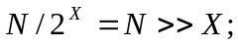
Note: You can also multiply by 2^{X} by entering “<<” instead of “>>”

Building the DLL:
First open Visual C++. Next, select File>New… Be sure that the Projects tab is selected, and choose Win32 Dynamic-Link Library from the list. Put the folder name where you want to store your project in the text box that is labeled Location. Type in your project name in the text box just above that. I am going to call mine “shiftdll”.

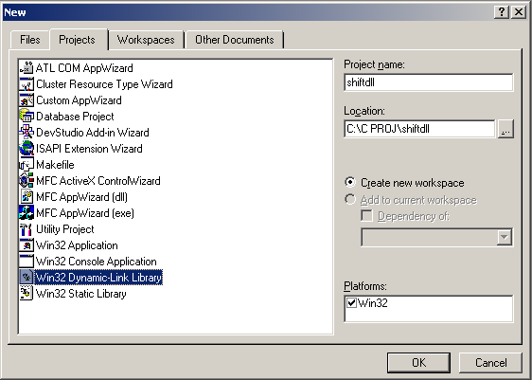
New project menu

At the next screen, select “A simple DLL project”, and then click the Finish button.
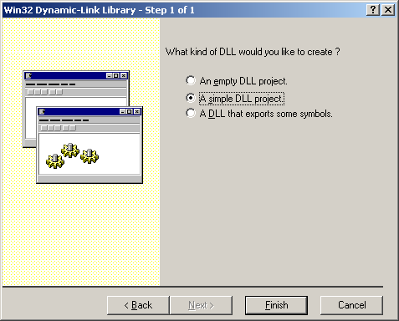
Now that we have our project created, we can view the code that has already been generated for us. The two files we will want to pay attention to are shiftdll.cpp and to a lesser extent; StdAfx.h

StdAfx.h
This file holds information that lets Windows know that it is a DLL and any other header files that your project will need. You do not have to worry about understanding any of the code, this simple DLL will not need any added header files, so we can leave it alone.

shiftdll.cpp
Here is the main file for our DLL. It holds any functions that you want to add. You can see that it contains one function already; DllMain(). We should leave this alone as well.
// shiftdll.cpp : Defines the entry point for the DLL application.
//

#include "stdafx.h"

BOOL APIENTRY DllMain( HANDLE hModule,
DWORD ul_reason_for_call,
LPVOID lpReserved )
{
return TRUE;
}

If we start a new line right after the last “}” of the file, we can add our own functions. I am going to add my function, BitShift, that will return an Integer data type.
Note: New functions do not require a “BOOL APIENTRY” prefix.
int BitShift(int inNum)
{
return inNum >> 1; //this will divide inNum by 2
}

This function is short but does exactly what we want. The actual programming of the DLL is complete but before we get to using it there is one file that is missing that is needed for Visual Basic to import the function.

Open Notepad or your favorite text editor. We will need to make a few definitions for our project. Simply enter the following into the editor.
LIBRARY "shiftdll_Library"
DESCRIPTION "Logical bit shift operation"

EXPORTS
BitShift @1

What does it all mean?
LIBRARY just defines the reference to the dll so VB can use it. This has to have “_Library” following the name of the project.

The entries under EXPORTS define the entry points for any functions that are in the dll. Because we only have one function, only one will be listed. Additional functions will need @# following it, in other words; if we add another function, we would add to our file: “function2 @2” (without the quotes of course)

DESCRIPTION is exactly as it sounds, you can put anything here describing your dll.

Now save the text from above as a file with the name matching the name of your project and with the extension of “.def”. In my case I will save as “shiftdll.def”. Be sure this is saved under the same folder as your project.

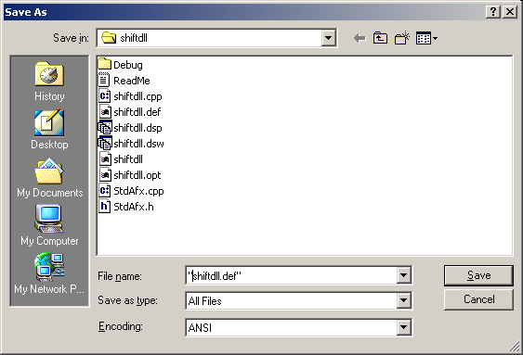
Saving the .def file

All you have to do now is add this file to the project. Select Project>Add to project>Files… from the menu. Then select the .def file from your project file.
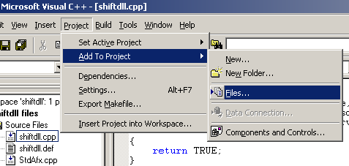
Adding the .def file to project

When you compile, you should get no errors and a dll will be made under the debug folder of your project. You may however receive a warning in the debug window. Though my professor has taught me better, I am going to ignore the warning; it should not cause any trouble later.

Are you fed up with programming yet? Well, here comes the fun part.

Building the Visual Basic application:
This is where everything comes together. As I write this tutorial, I am actually taking notes of each step as I create this project. I have confidence because this will be the second time I have made it.

Run Visual Basic and a selection box should appear.
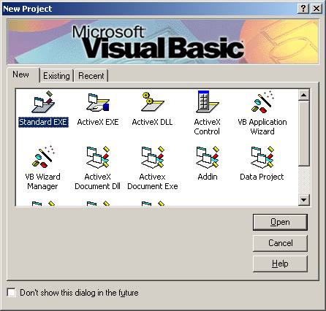
Choose “Standard EXE” and press Open (or OK if you have chosen New from the File menu).
You should see a blank form.
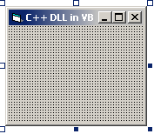

Next we need to add a button and a text box to the form by using the toolbar.
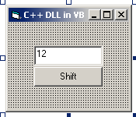
I have changed the following properties of the objects:

Object | Property | Value
Form1 | Name | frmMain
frmMain | Caption | “C++ DLL in VB”
Text1 | Name | txtInput
txtInput | Text | “12”
Command1 | Name | cmdShift
cmdShift | Caption | “Shift”

Now to set up the code:

Option Explicit
‘Here is the declaration that calls the function in the dll
‘Notice that the data type is Long. In Visual Basic, a long is 4 bytes, ‘and an Integer is 2 bytes while in
‘C++, both an int and a long are 4 bytes.
Private Declare Function BitShift Lib "shiftdll.dll" (ByVal Data As Long) As Long

‘When the button is pressed, the value in the textbox will be divided by 2 and the result will be placed back into the textbox.
Private Sub cmdShift_Click()
txtInput.Text = BitShift(Val(txtInput.Text))
End Sub

One thing to be sure about is to use ByVal in the declaration. This is what I had struggled with for most of the time I worked on it. Without the ByVal statement, the “Value” of the address of the variable is sent to the function. Though the function will return half of that number, it is not what we really wanted to send.

To keep things simple, I have saved my Visual Basic project in the debug folder of the dll project. Normally, Visual Basic can run a program without compiling. In the case of using a dll however, the dll will not be found unless the program is compiled, even if the project is saved in the same directory.
I have compiled my exe into the debug folder as well. The reason for this is because the dll must be in the same directory as your exe.
All that is left is to run the Visual Basic application and watch all of the work shine for itself. (see appendix A)
APPENDIX A: Application

Running

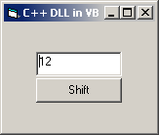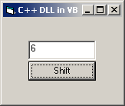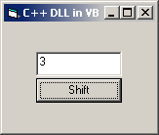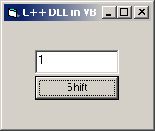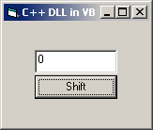
Note: There are no decimals because the program uses integers only.

Equivalent Steps in Binary:

Decimal | Binary (as a byte)
12 | 00001100
6 | 00000110
3 | 00000011
1 | 00000001
0 | 00000000
APPENDIX B: Visual Basic Code

Visual Basic Code:
Option Explicit
Private Declare Function BitShift Lib "shiftdll.dll" (ByVal Data As Long) As Long

Private Sub cmdShift_Click()
txtInput.Text = BitShift(Val(txtInput.Text))
End Sub

Visual Basic Form Script:

VERSION 5.00
Begin VB.Form frmMain
Caption = "C++ DLL in VB"
ClientHeight = 1665
ClientLeft = 60
ClientTop = 345
ClientWidth = 2325
LinkTopic = "Form1"
ScaleHeight = 1665
ScaleWidth = 2325
StartUpPosition = 3 'Windows Default
Begin VB.CommandButton cmdShift
Caption = "Shift"
Height = 375
Left = 495
TabIndex = 1
Top = 855
Width = 1320
End
Begin VB.TextBox txtInput
Height = 375
Left = 495
TabIndex = 0
Text = "12"
Top = 450
Width = 1320
End
End
Attribute VB_Name = "frmMain"
Attribute VB_GlobalNameSpace = False
Attribute VB_Creatable = False
Attribute VB_PredeclaredId = True
Attribute VB_Exposed = False
Option Explicit
Private Declare Function BitShift Lib "shiftdll.dll" (ByVal Data As Long) As Long

Private Sub cmdShift_Click()
txtInput.Text = BitShift(Val(txtInput.Text))
End Sub
APPENDIX C: C++ DLL Code

Module: shiftdll.cpp
// shiftdll.cpp : Defines the entry point for the DLL application.
//

#include "stdafx.h"

BOOL APIENTRY DllMain( HANDLE hModule,
DWORD ul_reason_for_call,
LPVOID lpReserved
)
{
return TRUE;
}

int BitShift(int inNum)
{
return inNum >> 1; //this will divide inNum by 2
}

Module: shiftdll.def
LIBRARY "shiftdll_Library"
DESCRIPTION "Logical bit shift operation"

EXPORTS
BitShift @1

Other Modules are generated by Visual C++

